**Mini Project Report on**



**Online Courier Tracking & Delivery System**



**Submitted in partial fulfilment of the requirement for the award of the degree of**

**BACHELOR OF TECHNOLOGY**

**IN**

**COMPUTER SCIENCE & ENGINEERING**

**Submitted by:**

**Y.V.VISHAL REDDY**

**University Roll No:**

**2017141**

***Under the Mentorship of***

**Mr. Pankaj Kumar**

**Designation**



**Department of Computer Science and Engineering**

**Graphic Era (Deemed to be University)**

**Dehradun, Uttarakhand**

**July-2023**



**CANDIDATE’S DECLARATION**

I hereby certify that the work which is being presented in the project report entitled **“Online Courier Tracking & Delivery System”** in partial fulfillment of the requirements for the award of the Degree of Bachelor of Technology in Computer Science and Engineeringof the Graphic Era (Deemed to be University), Dehradun shall be carried out by the under the mentorship of **Mr.Pankaj Kumar**, Department of Computer Science and Engineering, Graphic Era (Deemed to be University), Dehradun.

Name: University Roll no:

Y.V.VISHAL REDDY 2017141

**Table of Contents**

|  |  |  |
| --- | --- | --- |
| **Chapter No.** | **Description** | **Page No.** |
| Chapter 1 | Introduction | **1** |
| Chapter 2 | Literature Survey | **3** |
| Chapter 3 | Methodology | **4** |
| Chapter 4 | Result and Discussion | **8** |
| Chapter 5 | Conclusion and Future Work | **11** |
|  | References | **12** |

**Chapter 1**

**Introduction**

This project is aimed to provide better online delivery services to the consumers.Many people nowadays prefer to order online. The growth in online sales has rapidly grown in the past 5 years.The management maintains customers database, and improve delivery service.The Restaurant management systems motivates us to develop the system. There are various facilities provided so that the users of the system will get service effectively. So, they are interrelated.Increasing use of smart phones is also considered as a motivation, so that any users of this system get all service on single click. Another motivation can be considered as the system will be designed to avoid users doing fatal errors, users can change their own profile, users can track their items through GPS, Due to lack of a full fledge application that can fulfill the customer requirements by providing him item from the respective stores, there is a need for the system.. As well as, it will be useful for the students studying in different cities. The proposed system will provide the flexibility to the Customers/Users to order from either Restaurants or Mess.Also, same application can be used as a Startup Business for the developers. It gives appropriate feed backs to users, so if there is any error happened, then there will be a feedback dialog toward users. The proposed system is designed to avoid users doing fatal errors and inappropriate action.Scope of proposed system is justifiable because in large amount peoples are shifting to different cities so wide range of people can make a use of proposed system.The system/interface will take input from the user. The major attributes that will give input to the data set are: name, address,email-Id, mobile no, other personal related values, etc. The output will include a message from the store owner which will have the map with the co-ordinates of the delivery person doing the delivery.

**PROBLEM STATEMENT :**

The rate today of customers calling tracking agents as well as customer visits to

NIPOST offices to confirm the status of packages sent through NIPOST service

channels is very high. Sometimes, NIPOST agents cannot accurately say that the

package has been delivered due to insufficient communication with the company,

and secondly, are more prone to errors due to data loss. The data entry and validation

side of the old system was done manually, the system used the data entered to

schedule training sessions, all documents provided to customers were generated

from the data collected, and the data was processed for use. This process is often

associated with high levels of manual work, limited follow-up, and poor (at least

perceived) customer service. Effective proof-of-chain (POD) solutions are becoming

increasingly important to daily operations.

**Chapter 2**

**Literature Survey**

In this chapter some of the major existing work in these areas has been reviewed.

Most of the existing system focus mainly on food delivery system. There have been many implementations of this system,which are done by many online food delivery services like Swiggy, Zomato.This module is used only for one implementation that is food delivery.With the online food ordering method , food is ordered online and delivered to the customer. This is made possible through the use of electronic payment system .The payment can be done through the customer’s credit card ,debit card. So, int his project we design a system which will allow customers to go online and place order for their food. Due to the rapid growth in the use of internet and the technologies associated with it, the several opportunities are coming up on the web.So many businesses and companies arenow undertaking into their business with comfort because of the internet.

The proposed system proposes a system,which offers delivery services from any retailing store ,be it big or small to the consumer.It is aimed to expand the reach of online delivery system.The store owner signs up on the website ,from where he is redirected to his account, which contains the owner’s profile details,along with all the delivery men associated with him. The user is able to track the delivery boy’s position by going to their respective account, which will be provided on the map. It is assumed that the delivery boy will have a smart phone. On the delivery boy’s side ,his GPS co-ordinates will be sent to the owner via an Android application,which will be then sent to the owner. So the owner will able to track the item, he has ordered.The greatest advantage of this system is its FLEXIBILITY

**Chapter 3**

**Methodology**

The store-owner signs up with the website,and the credentials are stored in a database.After signing up, a confirmation mail with the link to the owner’s account is sent,after which the owner can log into access his/her account. The address entered by the owner is then converted to latitude and longitude, which are displayed on the map,the same goes for the client address. On the delivery man side, he will be connected to the system via a mobile application,where he will sign up from his mobile application and then he can login and as he enters his account, there will be a map which will have the store’s location and client’s location. When the delivery man starts from the restaurant for delivering,the GPS co-ordinates of his location is sent back to the owner, who sends the updated map with the location of the delivery,which is sent to the client.

The procedure followed in an online courier tracking system usually involves several

important steps and parts. Here's an overview of the methodology:

**Requirements Gathering**: The first step involves gathering requirements from

stakeholders, including courier service providers, customers, and other relevant

parties. This involves defining the desired tracking system features and functionality,

understanding user needs, and specific business requirements.

**System Design**: After the requirements are gathered, the system design phase begins.

This includes creating a high-level architecture and design for an online courier

tracking system. Design includes various components such as user interfaces,

databases, APIs, integration with other systems, and the flow of the entire system.

**Database design**: Designing the database structure is an important aspect of an online

courier tracking system. Database of shipments, customers, delivery personnel,

tracking status, etc. store important information related to database design ensures

efficient storage and retrieval of data while maintaining data integrity and security.

**Development**: The development phase involves the coding and implementation of

the online courier tracking system. This includes using the appropriate language,

framework and technology for the project. Developers create important functions

such as user registration and login, tracking status updates, creating messages,

synchronizing data, and notifications.

**Integration with Tracking Technologies**: An online courier tracking system should

integrate with various tracking technologies to provide real-time updates. This may

include integration with barcode or QR code scanners, GPS tracking devices or

RFID systems. This technology allows for accurate tracking of packages during the

delivery process.

**User interfaces**: It is necessary to develop intuitive and user-friendly interfaces for

customers, delivery personnel and managers to interact with the surveillance system.

This includes designing and implementing web or mobile interfaces that allow users

to track shipments, view delivery details, generate reports, and perform related tasks.

**Testing and Quality Assurance**: Thorough testing and quality assurance procedures

are essential to ensure the reliability and functionality of the online courier tracking

system. This includes unit testing, integration testing, system testing, and user

acceptance testing. It helps to identify and resolve bugs or problems, ensuring a

stable and error-free system.

**Installation and Maintenance**: After the testing phase is completed, the system is

delivered to a production environment that can be accessed by users. Regular

maintenance and updates are performed to resolve any issues, improve system

performance, and include new features or improvements based on user feedback and

evolving business requirements.

**Security Considerations**: Since the online courier tracking system involves the

handling of sensitive data, it is necessary to implement strict security measures. This

includes authentication mechanisms, data encryption, secure APIs, and adherence to

industry best practices to protect and prevent unauthorized access to user data.

**Continuous Improvement**: Online courier tracking systems must be continuously

monitored, evaluated and improved based on user feedback and evolving needs.

Regular updates, performance optimization and feature improvements ensure that

the system is effective, efficient and responsive to the changing requirements of

courier service providers and customers.

It should be noted that the actual methodology and specific steps followed may vary

depending on the project requirements, technology stack, and development

experience of the organization implementing the online courier tracking system

( Flowcharts associated )

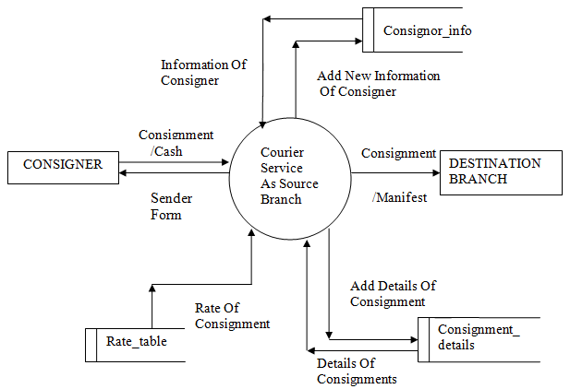

**Chapter 4**

**Result and Discussion**

This project is specifically designed for online deliveries, unlike online food delivery system, which are only used for food deliveries. As many people in developing countries like India are slowly getting to know about internet, it is safe to assume that online delivery is going to reach its pinnacle in the near future.

The website is likely to work in any modern web browser, which supports javascript and any latest android operating system from lollipop should suffice.

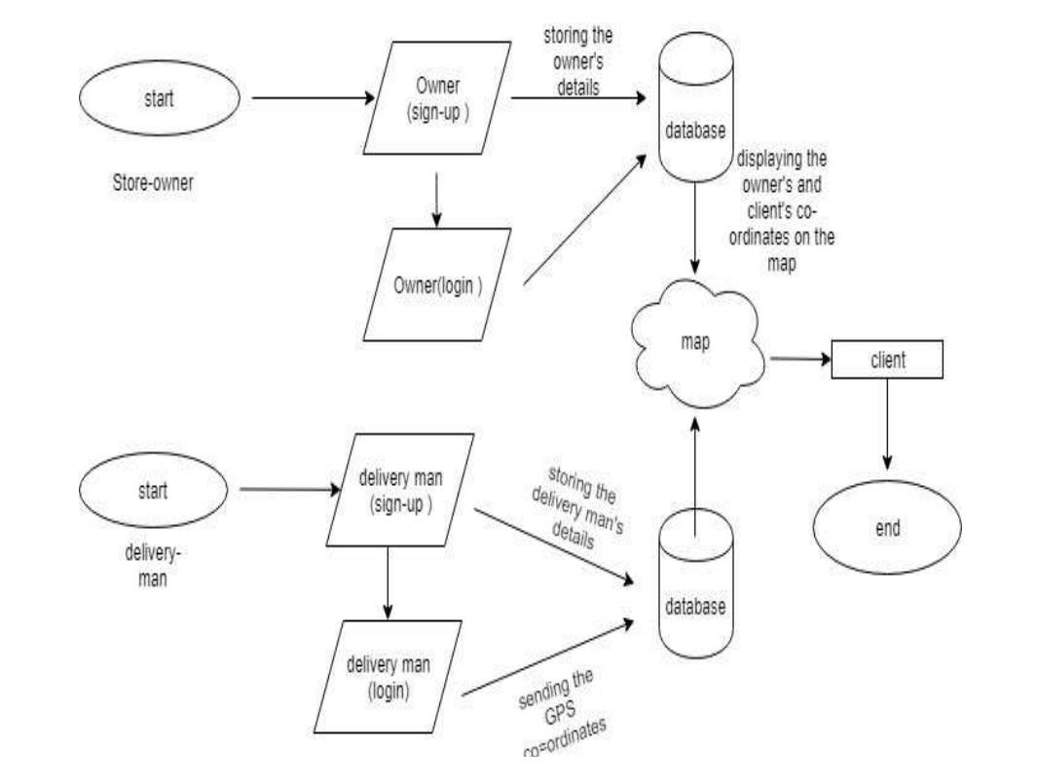

**Improve customer satisfaction**: One of the main benefits of an online delivery

tracking system is the increased customer satisfaction it provides. Customers can

easily track the status and location of their packages in real time, giving them peace

of mind and less worry about the delivery process. According to them, the estimated

delivery time is more visible, allowing them to plan and take the necessary actions.

This increased transparency and convenience has led to increased levels of customer

satisfaction.

**Improve efficiency and accuracy**: Implementing an online delivery tracking system

simplifies the delivery process and improves overall efficiency. Delivery service

providers can optimize their routes, manage resources efficiently and reduce

delivery delays. The system also reduces errors by providing accurate and up-to-date

tracking information, reducing incidents of lost or misplaced packages. These

efficiencies translate into cost savings and increased operational productivity for

businesses.

**Improved communication and support**: An online delivery tracking system enables

effective communication between customers, delivery personnel, and customer

service representatives. Customers receive automatic notifications and updates about

their shipments, keeping them informed throughout the process. In case of problems

or issues, customers can contact our customer support team using real-time tracking

information. This results in faster and more accurate problem resolution, resulting

in improved customer service and support.

**Data Analytics and Insights**: Online delivery tracking systems generate valuable data

that can be analyzed to gain insight into the delivery process. Businesses can track

and analyze key metrics such as delivery times, route efficiency and customer

satisfaction. This information can be used to identify areas for improvement,

optimize operations, and make data-driven decisions to improve the overall delivery

12experience. It also helps identify trends and patterns that can inform future strategies

and improvements.

**Competitive Advantage and Brand Reputation**: Implementing an online delivery

tracking system gives businesses a competitive edge in the e-commerce market.

Customers increasingly expect transparent and reliable shipping services and a

reliable tracking system can differentiate a business from its competitors. By

providing a positive and hassle-free delivery experience, businesses can improve

their brand image, increase customer loyalty, and attract new customers.

**Integration with other systems**: Online shipment tracking systems can be integrated

with other business systems such as inventory management, order processing, and

customer relationship management (CRM) systems. This integration ensures a

smooth flow of information across different departments, increasing operational

efficiency and reducing manual effort. It also provides a comprehensive view of the

order fulfillment process leading to better coordination and decision-making.

Overall, online delivery tracking systems offer many benefits, including increased

customer satisfaction, increased operational efficiency, improved communication,

data analytics capabilities, competitive advantage, and brand reputation.

**Chapter 5**

**Conclusion and Future Work**

This section will contain conclusion of your work. Further contains vision and ideas about future methods or new solution to your current problem statement.

The conclusion of such a system would be that it provides all the dynamics of the delivery with every recent update. The excellent combination of real-time information along with increased efficiency leads to quicker and proper delivery schedules. This increases customer delight, which in turn increases the loyal customer base.

As for future work, there are many areas where improvements can be made. One such area is to improve the accuracy of package tracking by using GPS technology. Another area is to improve the user interface of the tracking system so that it is more user-friendly and easier to use

**References**

**•**

Tan, Y., Lew, B., Tan, K., Goh, K.,Lee, K., & Khor, Z. (2010). A new Automated Food Delivery System using autonomous track guided centre-wheel drive robot.

2010 IEEE Conference on Sustainable Utilization and Development in Engineering and Technology

.doi:10.1109/student.2010.5686986

**•**

AHM Shamsuzzoha, RichardAkko-Tenkorang,

DuyPhuong

“Logistic Network:An Implementation issue for delivery network

” Technology Management in the Energy Smart World(PICMET)2011 Proceedings ofPICMET’11.